**Assembly-level Design for Additive Manufacturing framework supported by Axiomatic Design Theory**

**Ulanbek Auyeskhan12#, Clint Steed Alex 1#, Soohyung Park1, Dong-Hyun Kim2, Namhun Kim1\***

*1Department of Mechanical Engineering, Ulsan National Institute of Science and Technology, Ulsan, South Korea*

*23D printing Manufacturing Process Center, Korea Institute of Industrial Technology, Ulsan, South Korea*

**#These authors contributed equally**

**\*Corresponding author:** [nhkim@unist.ac.kr](mailto:nhkim@unist.ac.kr)

**Abstract**

The objective of this work is based on extracting the most desired assembly design based on integration of Design for Assembly (DfA), Design for Additive Manufacturing (DfAM) and Axiomatic Design (AD) theory. While utilizing AD, experiments were conducted to construct the design matrix though most other studies overlook this stage. Most significantly, this study involves determining the displacement error that occurs during manual assembly. This is especially important to overcome the lack of human aspects in AD, which is a known limitation. Involvement of human aspect would be very important, particularly at early design stages to assess reliability of assembly design which is aimed to be 3D printed. Manufacturers would be able to highlight design concerns related to human assembly prior to the design's manufacturing. In this regard a real industrial lifeboat hook assembly was tested in VR environment employing 10 human subjects. Using AD theory, we consider non-functional requirements from DfA (assembly time and displacement error) and DfAM (support volume). After going through the axioms of AD, the best design can be selected based on the design ranges set by a designer. Finally, to embrace practicality of the currently integrated framework, we present Graphical-User Interface (GUI) to aid manufacturers select the best assembly design based on AD.

1. **Introduction**

Before a design can be 3D printed, it must be thoroughly evaluated considering the design aspects of an assembly design. Thus, there is a need for a framework in the early phases of design to give a designer a thorough and methodical procedure. Not only should the framework be conceptual, but it should also have scientific foundations so that designers trust the objectivity of the prepared designs for Additive Manufacturing (AM). As a result, various early design efforts have been made, including DfAM-based recommendations, Inverse Problem Solving [1], TRIZ [2], and Axiomatic Design (AD) [3]. Here we use AD, which has been widely employed in a variety of fields for almost three decades. There are two axioms of AD such as Independence Axiom (AD-1) and Information Axiom (AD-2). Even though AD is frequently utilized in the design field, there have been some documented downsides. The first is the lack of a systematic approach for mapping and constructing a design matrix that depicts the relationship between functional and design domains. The other issue that has been brought up is the lack of human aspects in a product design, which is critical in the early stages of development when it comes to revising the product [4]. Furthermore, if an assembly has numerous components, there would be accordingly many part consolidation alternatives. Designers and engineers can sort out their intended assembly based on their experience; nevertheless, in this digital era, both theoretical and practical foundations are required to filter the feasible assembly design aimed for AM. To demonstrate, alternatives of industrial lifeboat hook assemblies are utilized in VR environment.

The purpose of this work is to present assembly-level DfAM framework based on AD addressing some of its current concerns.

1. Firstly, we document the real-world example of mapping non-functional requirements to the design domain by establishing a design matrix.
2. Secondly, we include human assembly aspects of product design. This was lacking from previous applications [4]. These aspects were included using experimental data.
3. Finally, the framework for evaluating consolidation alternatives is presented. This is an attractive development as part consolidation can yield many alternative designs that can be 3D printed.
4. **Methodology**

The proposed methodology relies on AD axioms which follows through manufacturing domain up until process domain. Characteristic to each assembly design, it is possible to select part consolidation alternatives to be utilized in the current framework. We conduct human assembly experiments in VR to obtain non-functional requirement data, namely, assembly times (nFR1) and displacement error (nFR2). Using these data, we confirm the Independence Axiom (AD1) can be satisfied between nFR1 and nFR2. This is crucial to building a design matrix between the functional and design domains. After this we choose the best assembly design based on AD-2 considering DfAM-constraints as well. Fig.1 illustrates the framework as a process. We have developed an in-house GUI, allowing the user to select the best assembly design.

1. **Brief Results & Discussion**

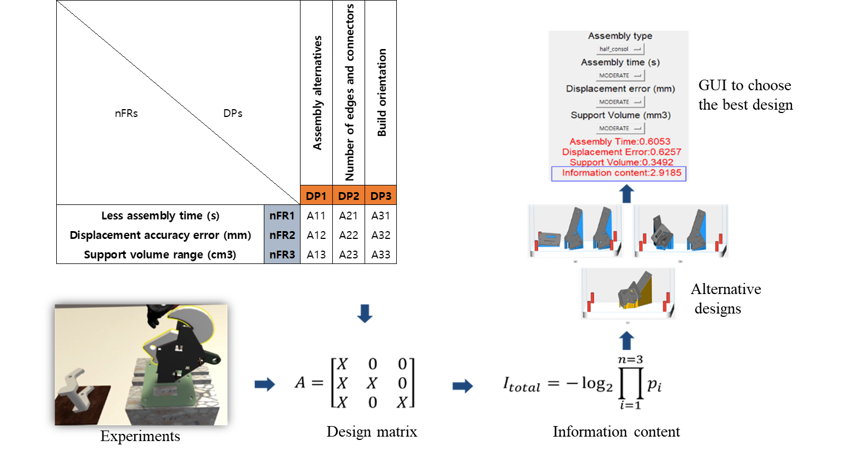Most studies tend to utilize normal distributions as it is easier to interpret, however, it is not the case in real applications. Thus, after data processing with Python, it was noticed that nFR1, nFR2 and nFR3 follow gamma, lognormal and uniform distributions, respectively. The fit was confirmed by Kolmogorov-Smirnov test (all p-values>0.05).

Figure 1. Process flow of framework. Starting with non-functional requirement decomposition, conducting experiments to obtain data, constructing design matrix, comparing alternative designs, evaluate using information content, present the result using GUI.

Based on the system ranges and design ranges of the given three hook assemblies, it is possible to compute information content, $I_{total}$, according to AD-2. The lowest $I_{total}$ indicates that a particular assembly has a high probability of meeting given nFRs, hence it is the best among others. We found the in-house GUI allows manufacturer to adjust design considerations assisting in the comparison between the remaining hook alternatives. The manufacturer is presented with the probability of success of satisfying the design range (Fig.2) based on their selection. In conclusion, following this novel framework with a practical application at the early design stages will filter the best assembly designs which are aimed to be 3D-printed.

Figure 2. The probability density plots graphically illustrate how well an assembly meets the requirements. The shaded area represents the probability of the design meeting its requirements.

**References**

[1] H. Rodrigue, M. Rivette, H. Rodrigue, M. Rivette, A. A. Design, and M. Methodology, “An Assembly-Level Design for Additive Manufacturing Methodology To cite this version : HAL Id : hal-01099485 An Assembly-Level Design for Additive Manufacturing Methodology,” 2015.

[2] S. C. Renjith, G. E. Okudan Kremer, and K. Park, “A design framework for additive manufacturing through the synergistic use of axiomatic design theory and TRIZ,” *IISE Annu. Conf. Expo 2018*, no. May, pp. 551–556, 2018.

[3] K. Salonitis, “Design for additive manufacturing based on the axiomatic design method,” *Int. J. Adv. Manuf. Technol.*, vol. 87, no. 1–4, pp. 989–996, 2016, doi: 10.1007/s00170-016-8540-5.

[4] J. R. A. Maier and G. M. Fadel, “Affordance based design: A relational theory for design,” *Res. Eng. Des.*, vol. 20, no. 1, pp. 13–27, 2009, doi: 10.1007/s00163-008-0060-3

**Acknowledgment**

This work was supported by the Korea Institute of Energy Technology Evaluation and Planning (KETEP) grant funded by the Korea government (MOTIE, 20193310100030), and the Nuclear Safety Research Program through the Korea Foundation Of Nuclear Safety (KoFONS) using the financial resource granted by the Nuclear Safety and Security Commission (NSSC) of the Republic of Korea. (No. 2003020)